Week 9
Date of planning:
Test 1
Name: ……………………………… | KIỂM TRA 1 TIẾT - MÔN TIẾNG ANH - LỚP 5
Class: …… | NĂM HỌC 2013 – 2014 - Thời gian : 40 phút

Marks: | Q.1 | Q.2 | Q.3 | Q.4 | Q.5 | Q.6 | Q.7 | Q.8 | Total

PART I. LISTENING (20’)
Question 1. Listen and draw the lines. There is an example. (1 pt)
Mary Petter Lucy


Tony Alex Linda

Question 2. Listen and tick the box. (1pt)

1. What did you do last night?
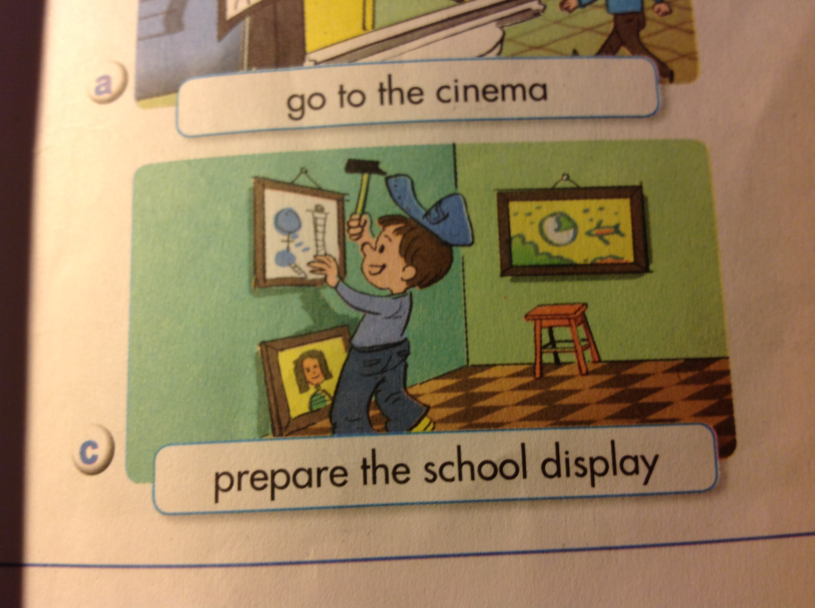  A. | B. 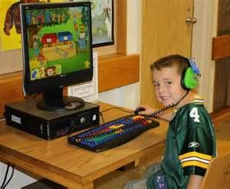 | C. 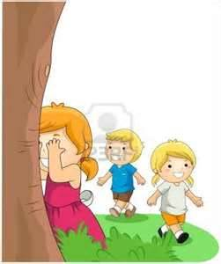
2. What will you be in the future ?
A. 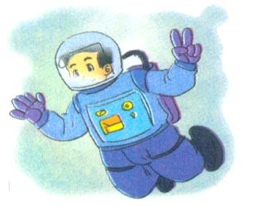 | B. 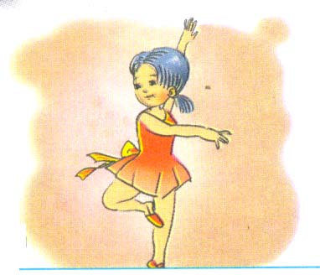 |   C.
3. What subject do you like best?
A. 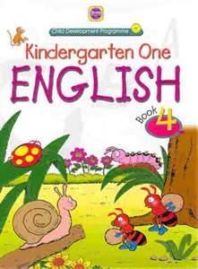 | B.  | C. 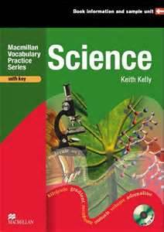

4. What is your favourite sport?
A. 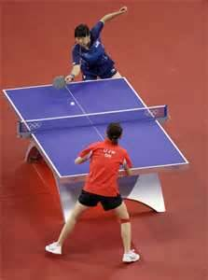 | B.  | C. 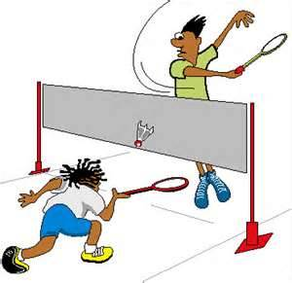

Question 3. Listen and number the pictures. (1 pt)
A.  | B.

C. | D.

Question 4. Listen and colour. (1 pt)
1. | 2. 
3.  | 4. 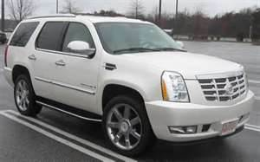
Question 5. Listen and write the words or number to complete the dialogues. (1 pt)
- What is her nationality?

- She is _______________.

- - What subject do you like best?

- I like ___________ .

- - What will you do at the weekend?

- I’ll play_____________with my friend.

- - Where do you live?

- I live in a ____________ in Hanoi.

PART II. READING AND WRITING (15’)
Question 6. Look and read . Choose the correct word and put them in the line (1pt)
Example: 0. dog

America | elephant | badminton
a pair of shoes | books | motorbike

1. Peter is from..............................He is American.
2. Tom likes reading..........................He is reading “Dragon balls”

3. What did you see at the zoo? I saw a big................................
4. What is your favourite sport? -It’s...............................................
Question 7. Read and colour. Insert the missing letters in the gaps. (1pt)
 | Tom Smith  Today is Monday.Tom goes to school early.He is in  front of the class now. He is wearing a pair of black  shoes,yellow trousers and a blue bag.There are some  b_ _ _ _ on the brown table.He takes a red book .He  stands n_ _ _ to the table and reads.
Question 8. Fill the gaps with suitable information in the box. Add words if necessary. (1pt) My friends’ future plans
Name | Tony | John | Mary | Lucy
Ability | good at sports and Maths | love music | good at Science | like drawing
Favourite job | astronaut | singer | scientist | artist
Reasons | fly everywhere | have a lot of money | discover | paint beautiful pictures
- Tony is ___________________________________ and he wants to be an astronaut.

- John will be a singer because he wants to________________________.

- Mary wants ___________________________so she will be a scientist.

- Lucy is going to be an artist because she ..............................................

Question 9. Look and read. Choose the correct words and write in the gaps . (1pt)
My house
I live in a house in the city. It is...................(1).....................I often play .....(2).....................with my brother in the garden.There are four bedrooms ,a livingroom and a beautiful kitchen.I often watch cartoon on T.V in ................(3) .................when I have free time.
There is a large ..........(4)..........Sometimes I play computer game on my bed.
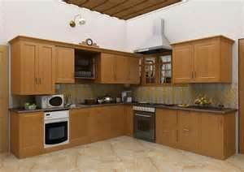
kitchen | a big house with a garden  in front | Hide-and-seek
 |  | 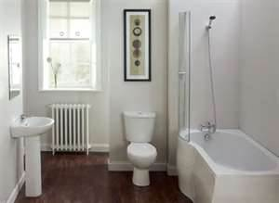
  
the living room | bedroom with a computer | a bathroom

Date of planning

Unit 6: A Visit to the Zoo
Lesson 1 - Period 1
1. Look, listen and repeat
2. Point, ask and answer

Class | Date of teaching | Absent students
5A  5B  5C |  | ………………………………………………………...  ………………………………………………………...  ………………………………………………………...

Aims | Ss will be able to:  -ask and answer questions about what people did at the zoo.
Language focus | Sentence patterns: What did you do at the zoo?  We walked around to see animals.  Vocabulary: animal show, zoo keeper, goose, moose, jungle, correct, burning hoop, horse, trick, snake, seal, mouse
Resources | Student’s book, CD, puppets, flash cards
PROCEDURES
1. Warm up: | -Ss sing the song We will go over the mountain from U5. | Whole class
2. Look, listen and repeat: | -Ask Ss to open their book on page 48.  -Get them to look at the title of the unit and the pictures to identify the characters.  -Set the context: Nam’s class had a visit to the zoo in the morning. Now Nga is asking him about the trip.  -Elicit Ss’ answers: Who is this? What’s his/her name? What are they talking about?  -Po0020int to each picture, read the text and check Ss’ comprehension.  -Pre-teach the new phrases:  Took us to the zoo  Walked around  Anything special  Had a picnic lunch  -Write the phrases on the board and get Ss to repeat each of them a few times.  -Play the recording twice: once for Ss to listen through and once for Ss to repeat.  -Divide the class into groups. Tell the groups to take turns to say the lines from Nga and Nam. | Whole class  Individually  T - WC
3. Point, ask and answer: | -Ask Ss to open the book on page 48.  -Set up the context: Imagine you went to the zoo yesterday. We’re going to practise asking and answering questions about your visit to the zoo.  -Ask Ss to read the example and elicit their prompts to complete the speech bubbles.  -Write the lines on the board.  -Get Ss to repeat the question and the answer a few times.  -Point to each picture in this section to recall the vocabulary and teach the new words:  Animal show  -Group the verbs into two columns on the board: one column is the base form of the verbs and the other is the past form. Get Ss to pay attention to the differences between the verbs form. Then ask them to repeat each verb a few times.  -Model the task with the whole class: Point to the girl in picture a and ask:  T: What did you do at the zoo?  Class: We took pictures.  -Repeat the step a few times. Focus on pronunciation and fluency. Then call on a few open pairs to go through the rest of the pictures.  -Pair work: Ss take turns to point to the pictures, ask and answer about the animals and activities at the zoo, using the pictures in this section. Monitor the activity and offer help when necessary.  -Select a few pairs to perform the task in front of the class. | Whole class  Whole class  Whole class  Open pairs  Pair work
4. Reinforcement: | -Ss play the game Slap that animal, using the flash cards of animals they have learnt. | T - WC
5. Homelink: | Ss select and draw one of the animals they like for the class display in the next lesson. | Whole class

Date of planning:
Unit 6: A Visit to the Zoo
Lesson 1 - Period 2
3. Listen and tick
4. Talk
Class | Date of teaching | Absent students
5A  5B  5C |  | ………………………………………………………...  ………………………………………………………...  ………………………………………………………...

Aims | Ss will be able to:  -ask and answer questions about what people did at the zoo.
Language focus | Sentence patterns: What did you do at the zoo?  We walked around to see animals.  Vocabulary: animal show, zoo keeper, goose, moose, jungle, correct, burning hoop, horse, trick, snake, seal, mouse
Resources | Student’s book, CD, puppets, flash cards
PROCEDURES
1. Warm up: | -Ss sing the song We will go over the mountain from U5. | T - WC
2. Listen and tick: | -Ask Ss to open their book on page 49.  -Tell them the listening purpose: You are going to listen and tick the correct picture in each number.  -Get Ss to look at the pictures and guess what they indicate.  -Give the meaning of the words: giraffe, loaf of bread, elephants trick  -Do the first example with pupils.  -Play the recording twice: once for Ss to listen through and once for Ss to do the task.  -Replay the recording for Ss to check their answers.  -Get Ss to correct their answers in pairs. Then ask some Ss to report their answers to the class.  Answers: 1.a 2.b 3.c 4.b  Tapescripts:  You are going to listen to different pupils talking about their past activities.  1. A: What did you do last Sunday?  B: I visited the zoo.  A: Oh, really? Who did you go with?  B: My brother.  A: How was the trip?  B: It was amazing.  2. A: What did you do at the zoo?  B: We walked around to see the animals.  A: Did you take pictures?  B: Yes, I did.  3. A: Did you have lunch at the zoo?  B: Yes. We had a picnic lunch. I was hungry. So I ate a lot.  A: Oh, really. What did you have for lunch?  B: I had bread and sausage.  4. A: What did you do after lunch?  B: We went to see an animal show.  A: Was there anything special?  B: Yes. The animals were clever and looked great. | Whole class  T - WC  Individually  Pair work
3. Talk: | -Draw Ss’ attention to the pictures in this section. Ask Ss to identify the animals and the activities in this section.  -Ask them to read the guiding questions. Then check their comprehension.  -Recall the vocabulary.  -Set the context: You’re going to practise talking, using the pictures and the guiding questions in your book.  -Do the first example with the whole class to give Ss a clear idea of what the task is.  -Pair work: Ss take turns to select the pictures, ask and answer questions about the contents of these pictures.  -Call on an open pair to demonstrate the task in front of the class. | Whole class  T- WC  Pairwork
4. Reinforcement: | -Ss play the game Slap that animal, using the flash cards of animals they have learnt. | T - WC
5. Homelink: | Ss select and draw one of the animals they like for the class display in the next lesson. | Whole class

*Home link: Ss make a list of their daily activitiesfor the class to displayin the next class. They practise asking and answering the questions about the items on the list

